

Curriculum Policy

Document History

Policy reviewed and adopted by Project Steering Group (on behalf of Local Advisory Committee)
Review frequency | Annually
Last Reviewed
Next review
Responsible Officer | Headteacher

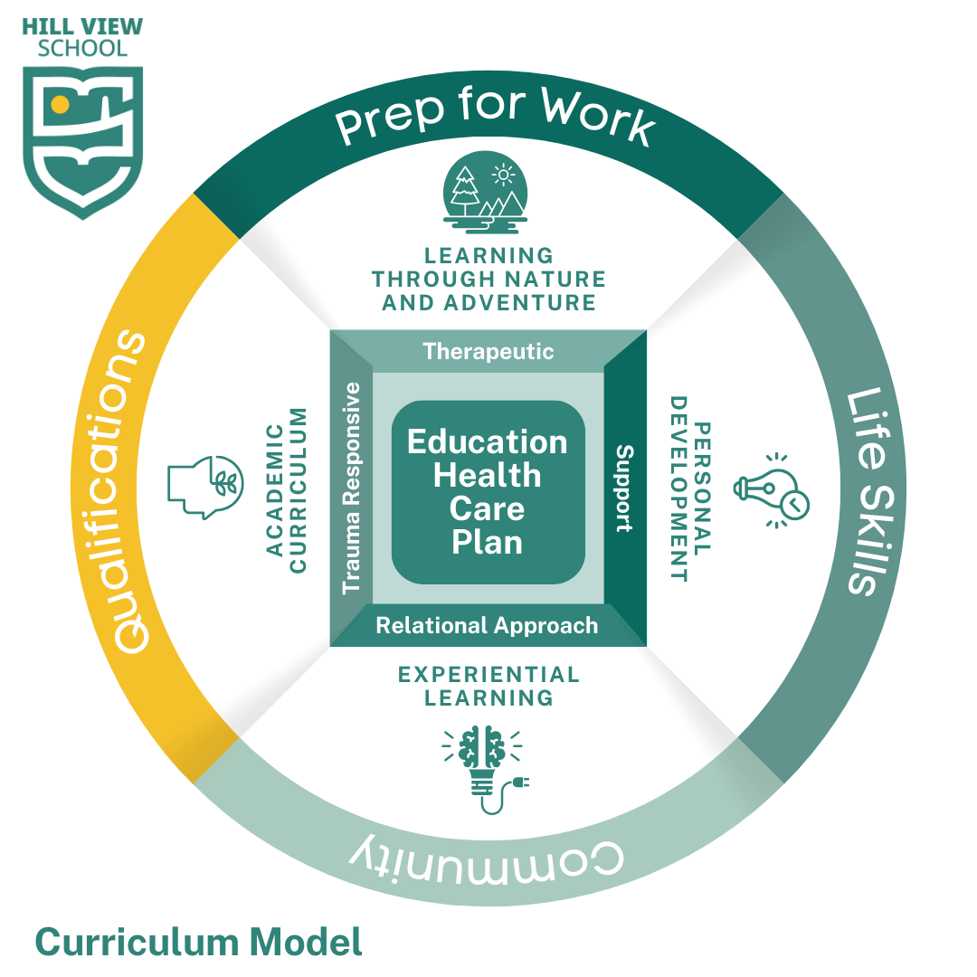

Curriculum Aims

1. Personalised Learning: To identify and cater to the individual needs and strengths of each learner, ensuring successful progression in their learning journey.
2. Rich and Engaging Curriculum: To provide a curriculum that is rich in experiences, knowledge, understanding, and skills, fostering a love of learning.
3. Deep Understanding and Skills Development: To develop learners' knowledge, understanding, and skills by building upon their existing foundation and celebrating their strengths.
4. Independence and Autonomy: To equip learners with the skills and opportunities to become independent learners, reducing dependence on adult support and preparing them for success beyond Hill View School.
5. Active and Contributing Citizens: To empower learners to become valued members of their local and wider communities, fostering a sense of responsibility and participation.
6. Growth Mindset and Celebrate Progress: To celebrate all forms of progress, no matter how small, nurturing a growth mindset in learners where they value the process of learning and achievement.

These curriculum aims are underpinned by our values:

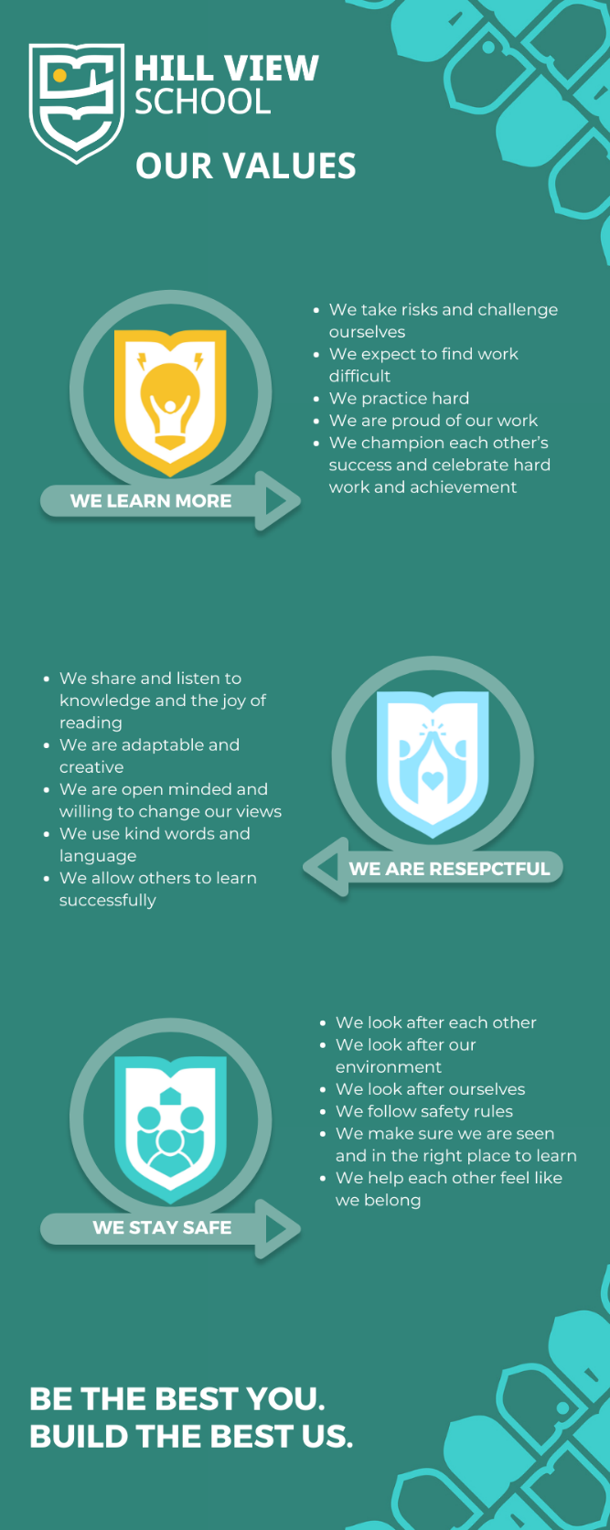
Hill View School Curriculum Policy: A Curriculum For The Future

Recognising Diverse Learner Needs:

Hill View learners come from a variety of social and cultural backgrounds, with diverse experiences in education. These backgrounds, along with individual needs that can change rapidly (both academically and socially), create a unique learning environment.

We address this diversity by providing a common set of experiences with high aspirations for all, while also recognising and adapting to the specific needs of each learner. Our curriculum prepares learners for their next steps in life, fostering a love of continuous improvement and lifelong learning.

A Purposeful Curriculum with "Routes to Success":

The "Routes to Success" curriculum prioritises purposeful learning experiences tailored to each learner's needs and starting point. We expose learners to a variety of opportunities and approaches, ensuring a well-rounded education.

Building on Individual Strengths:

We believe in identifying what is most crucial for each learner to progress on their learning journey. Our rich curriculum offers a balance of experiences, knowledge, understanding, and skills development. To achieve this, we:

- Know our learners well: This includes understanding their families and other stakeholders involved in their education.
- Build upon prior knowledge: We establish a foundation by starting with what each learner already knows, understands, and can do.
- Celebrate strengths: We acknowledge and celebrate areas where learners excel.
- Provide opportunities for success: Our "wider curriculum" (name to be confirmed) offers opportunities for success and achievement through firsthand learning and experiences. Examples include "[Pledges]" (to be confirmed) and "[99 Things to Do]" (to be confirmed).
- Develop independence: We create opportunities for learners to reduce their reliance on adult support, preparing them for a successful and purposeful life beyond Hill View.
- Nurture community members: We help learners become valued members of their local and wider communities.
- Celebrate progress: We acknowledge and celebrate every step forward, no matter how small.

Delivering the National Curriculum:

Our "Routes to Success" curriculum ensures the delivery of core subjects and other National Curriculum areas.

Individualised Learning with "Routes to Success":

Using an individualised approach, teachers continually build upon learners' existing experiences, knowledge, understanding, and skills. This is achieved by understanding each learner's aspirations and future goals, whether it be their next transition point or life beyond Hill View.

What Does Learning Look Like at Hill View?

- Lifelong Learning: We believe learning is a lifelong journey that extends beyond the classroom walls.
- Varied Learning Styles: We acknowledge that learners have different learning styles and progress at their own pace.
- Overcoming Barriers: We recognise that some learners need support to overcome challenges that hinder their progress. This support will vary depending on the individual needs of each learner.
- Non-Linear Learning: Learning is not a linear process, and we understand that learners may take different paths to achieve understanding.
- Building Strong Foundations: Our "Routes to Success" curriculum provides a solid foundation upon which learners can build their knowledge and skills, preparing them for their future endeavours.

Informed by Science:
At Hill View School, we understand that each learner brings a unique set of experiences and starting points to learning. Science tells us that early life experiences, including medical issues like traumatic births, time in neonatal care, and challenges understanding complex needs, can significantly impact a learner's brain development. This policy acknowledges this science and its implications for education.
Attachment- and Trauma-Informed Approach:
We embrace an "Attachment- and Trauma-Responsive" approach to education, recognising that some learners may have experienced disrupted early attachments. This awareness, grounded in scientific research, guides our curriculum and fosters a safe and supportive learning environment.
Our curriculum is informed by Dr. Bruce Perry's "bottom-up" Neurosequential Model of brain development. This model, supported by neuroscience research, suggests that the brain develops from the most basic functions (survival) towards more complex ones (reasoning and learning).
Many of our learners may still be in the early stages of brain development, relying heavily on their "primitive brain" for basic survival and safety. Therefore, our curriculum prioritises strategies for regulation (managing emotions and stress) and relationship building. This creates a safe and secure environment where learners can build strong connections with staff and peers. As Dr. Perry suggests, "Relationships heal relationship trauma."
"Regulate, Relate, Reason" serves as the foundation of our approach. Following the "bottom-up" approach, we first aim to support learners with skills for self-regulation. Then, we focus on developing strong, trusting relationships. Finally, with a regulated nervous system and secure relationships in place, learners are better prepared for formal learning and reasoning skills development.
In planning individual learning journeys, we prioritise a learner's "brain age" over chronological age. Brain science indicates that for many learners, healing and development of the brainstem and limbic system might take precedence over formal learning. Personalised Learning Plans may emphasise "regulation" and "relating" skills, laying the groundwork for future academic success.
The Hill View Curriculum fosters flexibility for both staff and learners. It allows for personalised, learner-centred approaches that cater to each learner's unique needs and learning pace. This flexibility empowers staff to prioritise "regulation" and "relating" when necessary, ultimately unlocking a learner's full learning potential.
Our approach and practice are not simply based on good intentions but are informed by the latest scientific research on brain development and the impact of early learnerhood experiences. We believe this scientific foundation is crucial for creating a learning environment that empowers all learners to succeed.

The 'Routes to Success' Curriculum
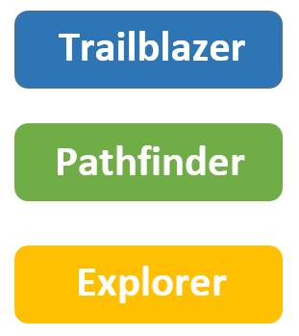
The 'Routes to Success' Curriculum has three ‘Routes’. These ‘Routes’ consider the needs of learners and the ways in which they will make best progress. This means that the ‘'Routes to Success'’, whilst they may on occasion teach the same area of study, will have different approaches to learning. All ‘Routes’ have a planned curriculum approach and whilst they are taught by skilled staff, not all will be taught by subject specialists. All ‘Routes’ consider the individual learner and wider stakeholders hopes for their future. All have high expectations and do not limit their learning journey. Learners can move fluidly between curriculum approaches to ensure the curriculum is matched to their needs and does not limit any talents they may have.
Class groupings are based on 'Routes to Success' but also consider the key stage, dynamics of individuals and the group of learners. This ensures every learner has the best opportunity to make progress.
The Intent
The Hill View School curriculum is designed to promote the social, moral, spiritual and cultural development of our learners as well as their intellectual and physical development. The aim of our curriculum is to engage learners as active participants in their education and future. Hill View School is committed to providing a broad and balanced curriculum, based on the National curriculum for those learners of compulsory school age. The curriculum is intertwined with opportunities for learners to develop functional skills, social, emotional and independence skills as well as skills for working life. This approach supports all learners to be successful members of the community and able to contribute to the wider society around them, living successful and fulfilling lives. We value the importance of providing an adaptable approach which will vary from learner to learner, to ensure we maximise the progress that is made.
The Hill View Curriculum is designed to align with The Oak Partnership Trust curriculum Principles:
Principles upon which the TOPT curriculum is based:
KS1 and KS2
The “head, heart and hand” is a holistic approach (Orr, 1992 & Sipos, 2008). It illustrates the all-encompassing nature of transformative experience and ties relational knowing and involvement to the intellectual (Head), emotional (Heart) and behavioural (Hand). The 3H model proposes that any effective teaching and learning activity should embed these concepts. (Life Skills)
Our curriculum intent can be segmented into the head, heart or hand. In this way, the curriculum...
Head
· ...allows for multi-discipline collaboration, contributing towards the ability to plan and deliver an innovative and creative curriculum, with traditional subjects grouped in ‘domains;’
· ...has sequences of knowledge (and in its variety of forms; disciplinary, procedural, experiential and substantive) that allow learners to build upon previous learning. We understand the importance of cognitive science and the role this has in learners remembering learning and applying it at a greater depth;
· ...has been constructed and sequenced in recognition that curriculum coverage is a poor proxy to its strength (awareness of breadth Vs. Depth)
Heart
· ...meets the needs of all within our community, affording the flexibility to focus holistically on what is best for them at any one time;
· ...makes use of each school’s enabling environment. Practitioners understand the influence the physical environment has on each learner’s ability to engage with and succeed in the curriculum;
· ...supports the delivery of the school’s vision and values;
· ...gives a mandate to support leaders, teachers and support staff in the facilitation of greater learner self-regulation and independence as forms of improved behaviour for learning;
· ...provides a framework for all to thrive: meaningful participation, meaningful success, more joy (Baines, 2019).
Hand
· ...understands the importance of language acquisition and development of oracy skills, including its effect on our learner’s life chances. We recognise the impact that language has on reading and writing and therefore access to the wider curriculum;
· ...does not under-estimate the role that the planned and unplanned curriculum have on our learner’s cultural capital. Delivering rich learning opportunities is at the heart of our curriculum offer, particularly for the most disadvantaged learner;
· ...recognises the importance of ‘play’ and the arts.
...at KS1 and KS2 the Cornerstones Curriculum will be used as a basis for the planning and sequencing of learning in some of the traditional subject areas.
Social, Moral, Spiritual and Cultural
At Hill View School SMSC underpins everything that we do to support learners to become successful and valued member of society. Sessions that extend the boundaries of learning across the school, provide an enriching experience of education at Hill View School.
SMSC is promoted throughout all subjects through Hill View School values.
- We Learn More
- We Are Respectful
- We Stay Safe

More information can be found in the Hill View School SMSC Policy.

Explorer  Learner Characteristics | Pathfinder | Trailblazer
Explorer learners will follow the thematic curriculum which makes links to key areas of the NC with an emphasis on promoting communication, life skills and problem-solving | Pathfinder learners will follow the thematic curriculum, with learners offered discreet STEM, PE, Food Tech, PHSE, Creative Arts, Our World and Vocational/Enterprise | Trailblazer learners will follow the National Curriculum and subject specific learning. Primary will follow a thematic model, with subjects being taught in greater depth.
Learner characteristics  - Intentional communication of needs and wants  - Developing levels of comprehension  - Developing appropriate use of Social Communication.  - Greater contextual and social awareness  - Emerging problem-solving skills | Learner Characteristics  - Reciprocal communication  - Developing levels of independence  - Socially aware and shows want to engage, will regulate with prompts  - Developing understanding of abstract concepts  - Greater levels of comprehension and retention | Learner Characteristics  - Unlimited turns in reciprocal conversations  - Communicates for context  - Greater social awareness and ability to read social ques & self-regulate.  - Able to comprehend more complex concepts & high levels of independence
The Thematic Curriculum  - Multi-sensory experiences with an emphasis of cause and effect  - Opportunities to express needs and desires  - Make connections to the world around them | The Thematic/Core Curriculum  - Multi-sensory experiences used as a vehicle to promote meaningful learning opportunities and social interaction  - Focus on promoting independence and problem-solving skills  - Make connections to the world around them | The Subject Specific Curriculum  - Developing/ developed behaviours for learning which enables opportunities to express needs and desires  - Supporting and encouraging independence in planning learning  - Problem solves and is resilient in making connections to the world around them
Planning  Curriculum is delivered through themes/projects that makes links to NC Targets set from subject specific Flight Paths PLGs (APDR) linked to EHCPs are woven through all learning opportunities | Planning  Core subjects taught through themes/projects where appropriate; some non-core subjects taught discreetly.  Targets set from subject specific Flight Paths where appropriate PLGs linked to EHCPs are woven through all learning opportunities | Planning  All subjects taught discretely  Targets set from subject specific Flight Paths PLGs linked to EHCPs are woven through all learning opportunities
Assessment  Progress measured against Flight Paths and PLGs linked to the EHCP outcomes. This is captured on Evidence for Learning (EFL) | Assessment  Progress measured against Flight Paths and PLGs linked to the EHCP outcomes. This is captured on Evidence for Learning (EFL). Aspects of this route are blended so assessments will reflect both Explorer and Pathfinder assessments. | Assessment  Learners on this Route are measured against the National Curriculum via our flight paths and will be assessed against formative assessments. EHCPs are assessed using EFL, with evidenced captured using TAGS.


Our Routes to Success

The Explorer Route enables learners to interact and access the world around them as they Explore and observe. This Route reinforces our ethos through our values;

We Stay Safe: Explorer learners are supported by staff who are thoughtful but do not lower expectations or place ceilings on what can be achieved. Learners will be enabled to explore the world with confidence in their own abilities. Learners will experience a range of strategies to reflect on behaviours that occur so they can build resilience and increase their toolbox of appropriate responses to difficult experiences. The key strategies will involve the use of sensory stories, zones of regulation, therapeutic sessions, social stories, underpinned by our relational and trauma responsive approach. Supporting learners to develop an understanding of a safe world and how to be safe in it.

We Are Respectful: Explorer learners interact and discover the world around them. Staff are dedicated in being involved in learning and play, to role model appropriate social and emotional responses in all scenarios they find themselves in. This enhances the prosocial activities the learners experience making their learning safe, purposeful, meaningful and relevant to them.


We Learn More: Explorer learners will be supported by staff who will use feedback to help them identify learning outcomes and celebrate success. Initially staff will support learners gain the appropriate behaviour for learning with motivating activities used as a mechanism for engagement. Over time learners discover learning through play and concrete materials resulting in key skills being retained for later life, developing independence that will equip learners for life beyond Hill View School. Skills and knowledge are constantly repeated. Learning is life skills based. Teaching based on interest of learners leading into curriculum based activities. Outdoor based learning is encouraged alongside increased levels of physical activity delivered within our Learning through Nature and Adventure curriculum.

The Pathfinder Route continues to encourage and support learners to have the desire to experiment and challenge their knowledge, building on what they already know, understand and can do. This Route follows the expectations of the National Curriculum which is adapted to enable Hill View learners to engage with materials that will support them for life beyond Hill View School. This Route reinforces our ethos through our values;

We Stay Safe: Pathfinder learners typically have fleeting resilience and self-worth. At times they will rely on staff to support and advise when they are feeling anxious. Staff in turn will advise and/or direct the learners to remain safe. These interactions between staff and learners are small bespoke opportunities to reinforce positive behaviour. Over time learners can create a toolbox to help them recognise their thoughts and feelings and increasingly pick the appropriate response to calm, regulate and manage their own behaviour. Over time, when strategies are identified by staff and learners, staff will encourage an independent approach to regulate. Pathfinder learners will keep in mind their own safety but may not consider the safety of others in all that they do. We understand that the learners have the tools but do not always choose the right one.

We Are Respectful: Pathfinder learners will be supported to explore their wider environment through valuable opportunities to experience different environments, this might include learning outdoors, respecting their environment and their peers. These learning opportunities might be self-lead, informal, giving learners the chance to choose the activity, or developed through a structured approach, where staff will decide on the learning activity and reasoning, and will support the learner through direction. This Route expects learners to have the respect for their environment and the impact they have on it.

We Learn More: This Route does not expect that learners will make connections between learning themselves, but plans support to ensure that they are successful at relating new knowledge, skills and content to previously learned knowledge, skills and content. Pathfinder learners gain experience by being presented with structured problems to solve. These learning experiences will be designed to build on previous experience both formal or informal, developing thinking skills and offering

feedback related to learning outcomes. Pathfinder learners will experience new skills and topics that they wouldn't have experienced before, they will have the opportunity to explore this new learning through practical activities to gain conceptual understanding, these activities will be built into the sequence of lessons preventing misconceptions, thus making written tasks accessible and less daunting. Success will be celebrated at every opportunity.

The Trailblazer Route builds on and from the knowledge, skills and understanding previously experienced by the learner. This Route to success follows the expectations of the National Curriculum. This Route reinforces our ethos through our values;

We Stay Safe: Trailblazer learners will have high expectations of themselves, including in their own personal development such as resilience. They will rely on staff only when necessary, and staff in turn will encourage this independent approach to learning, discovery and consolidation. They will keep in mind their own safety and consider the safety of others in all that they do. The learners have the tools and are able to use them independently.

We Are Respectful: Trailblazer learners will experience subject specific study, providing learners with opportunities to experience and be challenged by meaningful and engaging contexts. They will respect these contexts and be respectful of themselves and others, giving themselves the opportunity to take part as much as they can.

We Learn More: Trailblazer learners will be given informal and formal feedback, highlighting their learning targets and outcomes. They may study a range of accredited courses and will be expected to, with support, manage the evidence required. Trailblazer learners will be inspired to undertake self interest study where appropriate.

The Routes Rationale

Our Routes can be thought of as the Route Path a learner is on. Each learner moves in the same direction and every Route is a safe place to learn, but they move at different speeds, with different waypoints and plot a different course. The ‘Map’ is where we navigate our journey along the Route. The map identifies all the aspects we need to engage in to be a well-rounded individual. It is how we take control of our journey.

The support we receive along the way can be seen as the waypoints which guide our path. Each Route heads in the same direction but some Routes have more waypoints than others. These waypoints make sure that learners have the support they need to continue their journey. The support ensures that learners have what they need to engage them in learning and ensure progress is made, supporting them to reach their end destination, whatever that may be.
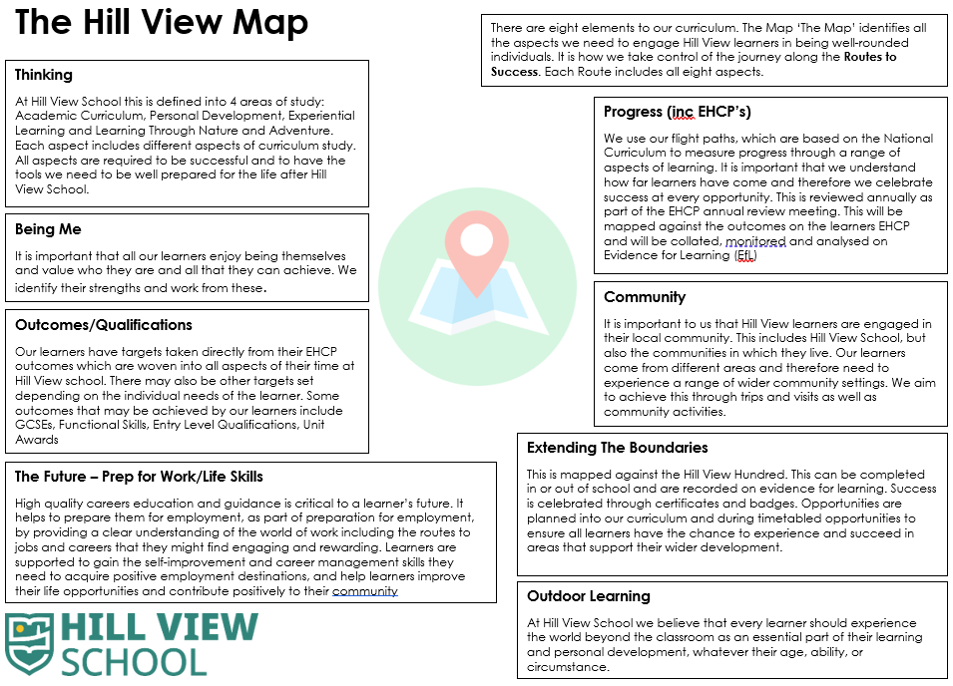

Nothing prevents learners transitioning onto different Routes and being supported by additional waypoints. This prevents any learner being limited by the curriculum Route they are on. We understand at Hill View School that learners face many different challenges, just like the challenges faced when navigating difficult terrain. Our role is to remove these barriers to enable our learners to navigate their journey safely and arrive at their next destination, life beyond Hill View School.

At Hillview School we believe that a carefully planned and structured curriculum is the foundation upon which excellent learning and development is built. Our curriculum is designed and implemented so that it builds on prior knowledge and prepares learners for the next stage in their education. Lessons are engaging, inspiring and appropriately scaffolded so that learners are able to achieve, or go beyond, their potential – we truly believe in having no ceiling to achievement.

Development of language and building knowledge are integral to curriculum planning. Domain Leaders work with other Oak Partnership colleagues to carefully construct a curriculum that promotes a deep understanding of a wide range of topics whilst also developing the Hillview values, using their subject knowledge and Hillview staff understanding of our learners needs.

Our ‘Routes to Success’ curriculum is built of four key elements: Academic Curriculum, Personal Development, Experiential Learning and Learning Through Nature and Adventure. Each aspect of curriculum is planned and adapted for each of the ‘Routes’. We adapt the curriculum with a focus on developing literacy skills as a key focus across all classes and year groups – learners cannot access the most engaging lessons if the literacy skills are not there to support. We have a whole school approach to develop literacy and this can be seen from all teachers and teaching assistants in all domains. Due to the nature of Hillview School, PSHE and personal development underpin the curriculum and can be observed across the school in every aspect of the learners' daily experience.

Curriculum Allocation

Primary
Subject/other activity | Lessons | Mandatory/ Voluntary | Comments / Schemes of Work | Delivery
Phonics | 5 | M | ELS  Fresh Start
Mathematics | 4 | M | TOPT Curriculum | White Rose Maths  Curriculum Maestro
CLL | 4 | M | TOPT Curriculum | Curriculum Maestro  Literacy Tree
STEM | 4 | M | TOPT Curriculum | White Rose Science  Curriculum Maestro
Our World | 3 | M | TOPT Curriculum | Curriculum Maestro
PE | 3 | M | TOPT Curriculum | Sport England
PSHE | 2 | M | TOPT Curriculum | Jigsaw
Creative Arts | 3 | M | TOPT Curriculum | Curriculum Maestro
Food Tech | 1 | M | TOPT Curriculum
Total | 29

Key Stage 3
Subject/other activity | Lessons | Mandatory/ Voluntary | Comments / Schemes of Work | Delivery
Phonics | 5 | M | Read Write Inc
Maths | 4 | M | Beyond Maths | White Rose Maths  Curriculum Maestro  My Maths
CLL | 4 | M | Beyond English  Literacy Tree
STEM | 4 | M | Beyond Science | White Rose Science
Our World | 3 | M | National Curriculum
PE | 3 | M | National Curriculum
PSHE/Careers | 2 | M | PSHE Association
Creative Arts | 2 | M | National Curriculum
Food Tech | 2 | M | Food a Fact of Life
Total | 29

Key Stage 4
Subject/other activity | Lessons | Mandatory/ Voluntary | Comments / Schemes of Work | Delivery
Interventions | 5 | M | Personalised
Maths | 4 | M | GCSE, Functional Skills, NCFE Essential Skills, Entry Level | My Maths  White Rose
CLL | 4 | M | GCSE, Functional Skills, NCFE Essential Skills, Entry Level
STEM | 4 | M | GCSE, Functional Skills, NCFE Essential Skills, Entry Level
PE | 2 | M | Youth Sports Trust
PSHE/Careers | 2 | M | PSHE Association
Food Tech | 2 | M | Food a Fact of Life
Motor Vehicle | 6 | V | NCFE qualifications
Art & Design | 6 | V | NCFE qualifications
Catering | 6 | V | NCFE qualifications
Health and Beauty | 6 | V | NCFE qualifications
Animal Care | 6 | V | NCFE qualifications
Construction | 6 | V | NCFE qualifications
Computer Science | 6 | V | NCFE qualifications
Sport & Fitness | 6 | V | NCFE qualifications
Total | 24
Work Experience | 25 | M | Year 10

Organisation and Planning

The long-term planning approach, for the benefit of coverage and planning medium-term, will derive from The Oak Partnership Primary Curriculum.

- A planning directory is used by staff (SharePoint) – each subject domain populates a folder with each year group folder within. Within each year group folder will be half termly folders each with a half termly overview for that subject.
- The half termly overview document will:
- ask teachers to consider the adaptations needed when taking from a ‘mainstream’ teaching sequence
- give room/prompt for ongoing formative assessment notes (part of the formative assessment policy) – executed to influence the next day’s teaching, this also acts as the short-term planning mechanism

Each year group will have a physical & digital copy that the teacher/s will use to plan from and highlight coverage. These copies will move through the school, with the year group to the next teacher/s.
Upon transition to KS3, this will support KS3 and KS4 teachers in ensuring the approach taken builds upon curriculum coverage from KS1 and KS2 as well as each learner’s strengths and areas of development.

The ‘curriculum’ offers the spectrum of possibility; Hill View leaders will monitor the coverage taught with a view that the entirety of the composite objectives may not be taught.
Curriculum Construction

As a SEMH/SLCN school, we recognise that the construction of the curriculum needs to have language and literacy as the key curriculum driver:

At Key Stage 1 and 2, Literacy Tree Curriculum Map provides the driver for cross-curriculum links.

SEE APPENDIX 1

CURRICULUM BY KEY STAGE

Key Stage 2

In the mornings, every learner access English and Maths - reading is a priority. In addition the timetable allows for whole school phonics intervention which is delivered through ELS and Fresh Start.

Other academic subjects are embedded into the Cornerstones Curriculum. The Cornerstones Curriculum (Curriculum Maestro) is delivered through ‘Big Projects’.

In the afternoon, every learner accesses a personal development curriculum with aspects of experiential learning. This includes explicit domains such as Our World, STEM, Food Tech and PE PSHE and PE, personalised interventions, and Learning Through Nature and Adventure.

Key Stage 3

All learners in key stage 3 access English and Maths with a particular focus on reading.
Other academic subjects are embedded within our curriculum, which is closely mapped to the national curriculum to keep our curriculum as broad as possible for as long as possible.
STEAM, Our World (Humanities), Creative Art, PE and PSHE (combined with RSE) are delivered through stand explicit lessons.

Learners in this key stage continue to access experiential learning including increased opportunities to gain confidence off-site.

Key Stage 4

In years 10 and 11 we start to focus on learners’ long term goals and adjust our curriculum accordingly. Every learner continues to study English, Maths, STEAM, PSHE, Food Tech and PE. Learners also access a range of accredited courses that are updated on an annual basis according to their needs and aspirations.

Learners continue to access experiential learning, which includes opportunities to complete work experience (see below).

Qualifications

In KS4, learners can access qualifications in the following areas: English, maths, science, citizenship, arts, food technology, sport, animal care and music. Our accreditation is updated on an annual basis to ensure it meets the needs and aspirations of our learners.

Careers Education at Hill View School

Hill View School is committed to providing a comprehensive Careers Education programme that equips learners with the knowledge, skills, and experiences they need to make informed decisions about their future.

Careers Education is seamlessly integrated into the PSHE curriculum for Key Stages 2 to 4. This ensures learners receive consistent and age-appropriate guidance throughout their academic journey.

We take a bespoke approach to Careers Education, identifying and addressing any barriers that may hinder a learner's participation in education and employment. We are committed to ensuring equal opportunities for all.

In line with the Baker Clause, all Hill View School learners from Year 7 onwards have at least one encounter with an employer or workplace and one encounter with a further education or apprenticeship provider each year. These encounters provide valuable first-hand insights into different career paths. We keep Labour Market Information at the forefront of our Careers Programme, ensuring learners are aware of current and future job trends. This allows them to make informed decisions about their studies and future careers.

Our annual Careers Week is a highlight of the school year. During this week, we invite a diverse range of local employers from various industries to visit our school and interact with learners. This allows learners to explore a wide range of career options and network with professionals.
All Key Stage 4 learners have the opportunity to participate in Work Experience placements. We partner with local businesses to provide learners with valuable real-world work experience. This experience helps them develop essential workplace skills and gain a better understanding of potential career paths.

We recognise that academic qualifications are just one aspect of a successful future. Our Careers Education programme works in tandem with our academic curriculum to ensure learners have a broad range of options to consider for their post-16 education and careers.

We collaborate closely with our partners across Somerset to deliver a high-quality Careers Education programme and support our learners in achieving positive career outcomes.

ICT to Improve Learning

Computing is taught within our STEAM curriculum to better equip learners for living and working in an increasingly digital world. Although there is a greater degree of flexibility in how the curriculum is taught in special schools and similar settings, we have a clear duty to deliver this subject and have a vision for doing so.

Additionally, the use of technology to support and enhance the progress of all learners will be considered. In an increasingly technology-rich world where many learners rely on technology for communication and access to learning, we have a vision to ensure that the appropriate hardware and infrastructure is in place for using computational thinking as a framework for teaching problem-solving across the curriculum. The transferability of computational thinking skills is key with the benefits to learners with specific communication integral to the overarching curriculum vision. Investing in the right hardware and software at the right time will underpin the wider Trust’s Digital Strategy and this goes hand in hand with developing teacher confidence to deliver an effective digital curriculum as well as the use of technology to support wider learning.

Hill View School is home to a passionate community of educators, with a collective resource of experience, imagination and creativity that is used to adapt the curriculum meaningfully to meet the needs of individual learners.

Reading

As a school, Scarborough's Reading Rope (below) is a fundamental model that illustrates our understanding of how to enable skilled reading within learners at our schools. We promote rich reading opportunities within which these 'strands' develop over time with more teaching and experience. With practice, we aim to ensure that the 'Word Recognition' strands become increasingly automatic so our learners become fluent readers, and we teach the 'Language Comprehension' strands with the view that learners become increasingly strategic in their use as they meet texts that are more complex.

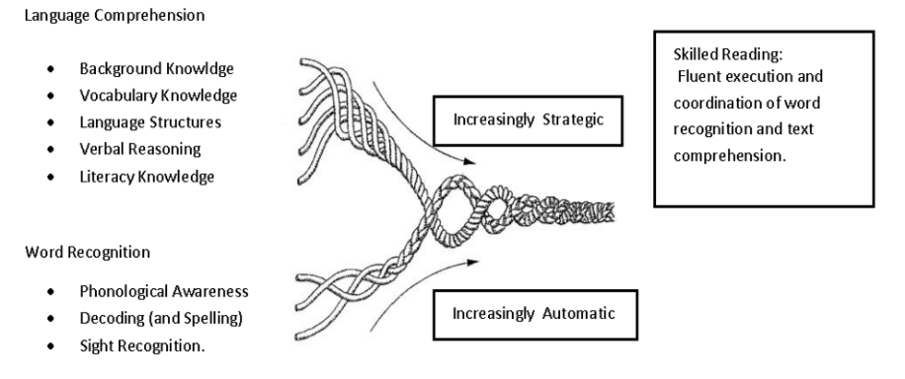

Phonics

Phonics will be taught with fidelity throughout KS1 and where appropriate at KS2 and KS3.
- KS1 SSP – ELS
- KS2/3 - ELS
The teaching of reading beyond phonics follows the Wayne Tennant teaching cascade with an emphasis on vocabulary work (particularly Tier 2 and Tier 3 words).

Communication

Much of the CLL work will be based on high-quality texts linked to cross-curriculum work (Literacy Tree). Learners will enjoy a wide and varied range of texts and genres. Key skills in reading, communication (writing), speaking and listening will be developed and consolidated upon, before learners are challenged through a range of exciting learning opportunities.

- The CLL Approach planning sequence of Engage, Embed and Create will be used;
- The key text will be linked to cross curriculum ideas and concepts;
- Teaching and learning will reflect and support the overall development of English with a great emphasis on modelled, shared and guided writing during the Embed Stage;
- Leaders will engage in the text using a variety of creative strategies including drama and role play to widen their understanding.
- Leaders will be given the opportunity to work within a variety of learning situations including whole class, guided, independent, group and paired work.
- Differentiated and challenging activities will be given to support and extend.
- A whole school spelling programme will be used to ensure engagement and coverage of spellings.
- Grammar will be taught where it links to the high-quality text and can be applied in the subsequent writing to provide relevance and purpose.
- Planning reflects a learning journey through a unit of work. Like all journeys, the plan has a specific destination and journey time. Teachers work from a medium-term plan. The planning is based on a high-quality text often linked to other curriculum subjects (Literacy Tree & Curriculum Maestro). An audience and purpose are also planned from the start.
- Planning is a flexible document working alongside the use of the assessment for learning to respond to the needs of learners. This is particularly important in the Engage Stage (assessment of reading) and during the Embed stage in response to the teaching of text and language features.

Oracy

There will be a commitment to centre oracy teaching and learning across the school. This aims to enable all learners to access and benefit from a high-quality oracy education. We will subscribe to the Voice 21, which is a national oracy charity who support and guide our steps. The deliberate, explicit and systematic teaching of oracy across phases and throughout the curriculum will support our community to make progress in the four strands of oracy outlined in the Oracy Framework:

Talk tactics will be used across the curriculum and displayed in every classroom from Y2 upwards:
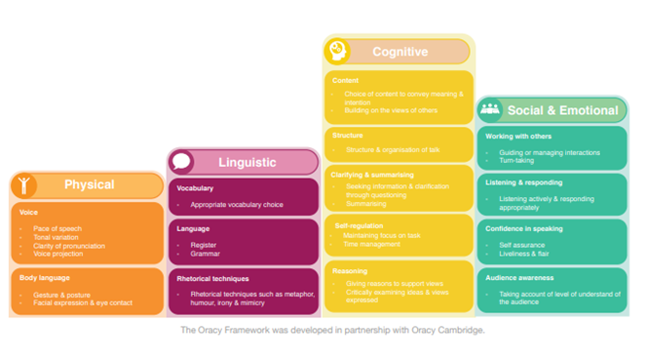
Literacy Intervention/Catch-up

Practitioners will deliver the Individual Literacy Intervention (ILI) at KS3 and KS4. ILI is a tailored 1:1 intervention that aims to double the rate of reading and spelling progress. Adapted teaching, considering the learners’ needs would need to be considered as opposed to delivering the programme with complete fidelity.

Inclusion

Hill View School is committed to ensuring that appropriate and well-planned provision is made for every learner.

We will offer a fully inclusive education within our specialised environment and provide aspirational provision which focus on improving outcomes and raising attainment for all learners.
The views of our learners and parent carers are central to our provision; for our learners to have a voice will be essential to a sense of belonging and progress being made.

We will work closely with the wider community and other support services with the aim of providing the best possible learning experience for all.

Gifted and Talented (G&T)

All learners at Hill View School are entitled to a structured, balanced and challenging curriculum that is suited to their needs and their aspirations. Providing enriching learning experiences for all our learners is vital and this includes provision for the most able. We believe that the development of provision for our talented and most able, and exceptionally able learners will improve provision for learners of all abilities.

To achieve this, systems will recognise and support the abilities, personal qualities and talents of all learners as well as promote a culture of high expectations for all learners. Leaders will develop a recognition and awareness of talented and most able learners and their individual strengths, ensuring that all teachers share responsibility for the monitoring of learners, including the most able.
We recognise that opportunities for all learners to develop their strengths through high quality curricular activities in a variety of specialised areas is key – this could then include specific provision for gifted, talented and able learners.

English as an Additional Language (EAL)

Our approach to the teaching of learners with EAL is underpinned by the Bell Foundation.

EAL pedagogy is underpinned by the following principles:
- Bilingualism and multilingualism are assets.
- Cognitive challenge should be kept appropriately high.
- Learners’ proficiency in English is closely linked to academic success.

To maintain these principles, we will need to ensure the following teaching strategies are effective:

Given the principles underpinning EAL pedagogy, effective practice for learners using EAL is likely to include:
- Activating prior learning
- Providing a rich context
- Making the English language explicit in the classroom
- Developing learners’ independence
- Supporting learners with EAL to extend their vocabulary
Underpinning the approach to teaching and learning is an understanding of how their EAL needs are met alongside those of a SEMH/SLCN nature. Staff will be aware of the following when planning to meet all needs.

- the possibility of new cultural expectation.
- emotional wellbeing.
- the capacity for successful social Interactions.

Looked After Children (LAC)

The mental health of looked-after children is significantly poorer than that of their peers, with almost half of children and young people in care meeting the criteria for a psychiatric disorder (Mental health and well-being of looked-after children, 2016).

The above statement is well considered when building teaching and learning as well as leadership systems and processes for LAC and PLAC. Leaders of Hill View School recognise that building relationships and trust as well as understanding the impact of fractured attachments is fundamental to working with LAC. The impact of the ‘temporary home’ and the balance of safety vs survival, for some of our LAC learners, could impact successful school experiences. Both the curriculum itself and its delivery will be flexible to allow for this to be supported.

Training for staff – consisting of a basic knowledge of attachment theory – allows staff to appreciate some of our learners’ first relationships made as a learner become integral as to how they experience relationships going forwards. As part of our PEAK CPD programme staff will receive training to understand adverse childhood conditions (ACEs) and the effect this can have on behaviours will be considered.

Monitoring arrangements

Governors monitor whether the school is complying with its funding agreement and teaching a “broad and balanced curriculum” which includes the required subjects, through LSC workstreams and SIG meetings.

Subject leaders monitor the way their subject is taught throughout the school through LRW workstream activities that are determined at a Trust and School Leadership level.

Subject leaders also have responsibility for monitoring the way in which resources are stored and managed.

This policy will be reviewed every Learning Review Week Cycle by SLT and subject leads. At every review, the policy will be shared with the LSC.

School improvement and governance systems will use Trust produced ‘workstreams’ that allow for leaders at all levels to understand the impact of leaders’ work and its links to allocated funding. The workstreams are implemented at a local level of governance and then monitored by Trust leaders and reported to Trust Directors.

Links with other policies

This policy links to the following policies and procedures:
- Assessment policy
- SEN policy and information report
- Equality information and objectives

APPENDIX
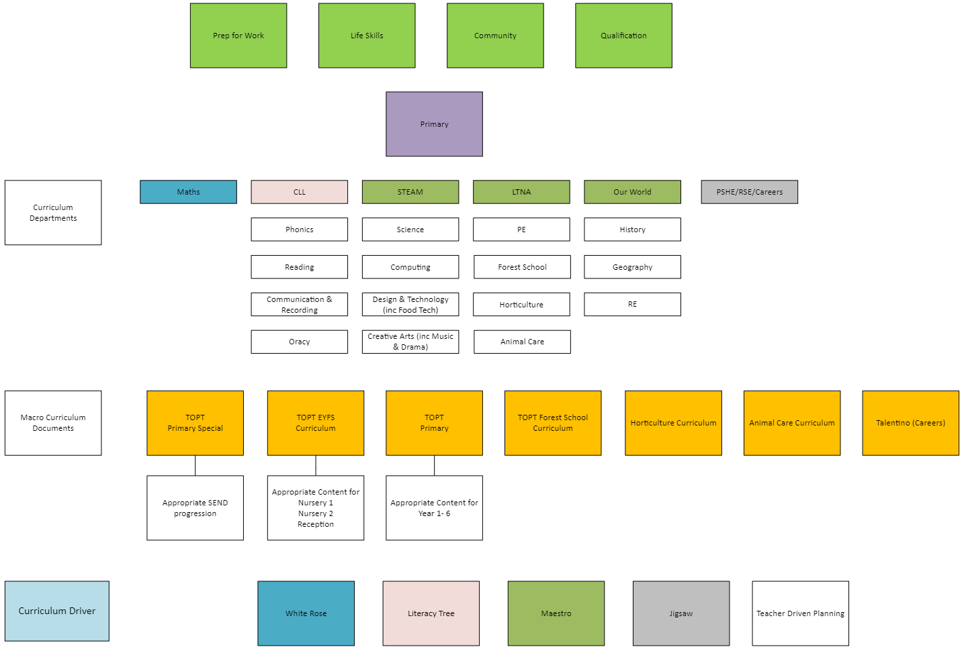

Primary Curriculum Structure

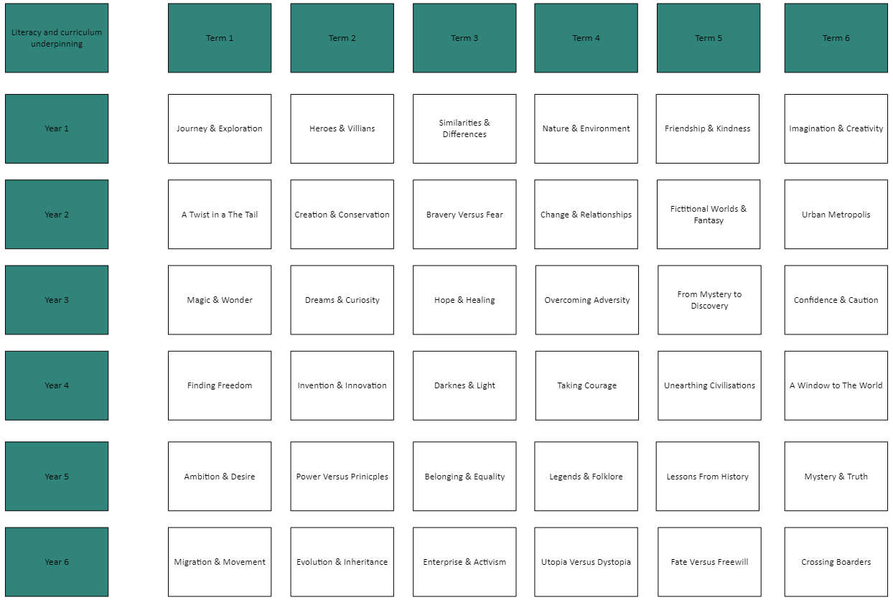
Literacy Underpinning The Curriculum: Primary
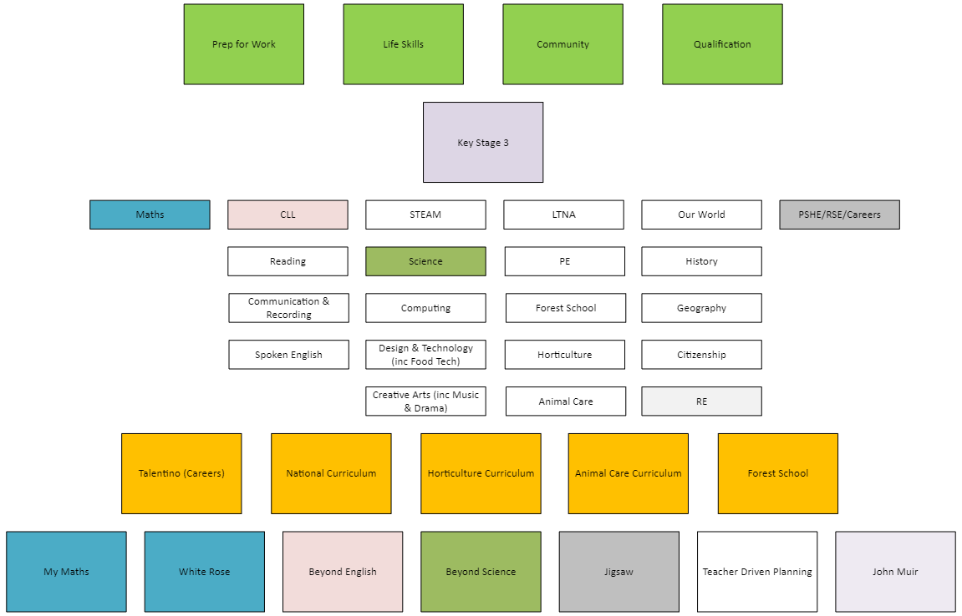
Key Stage 3 Curriculum Structure
Literacy Underpinning The Curriculum: Key Stage 3
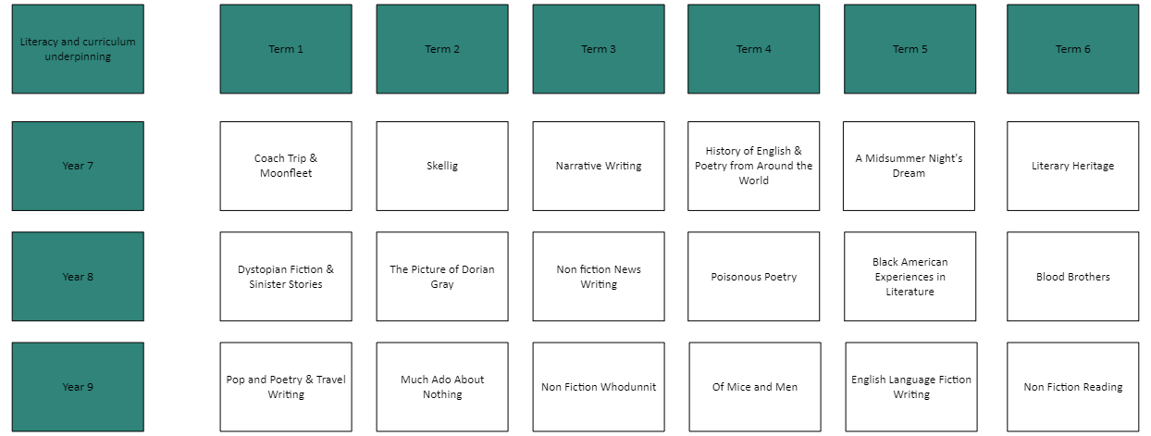

Key Stage 4 Curriculum Structure



