Getting ready for my new school.

In September I am going to go to Hill View School.
This is what the front of my new school will look like.
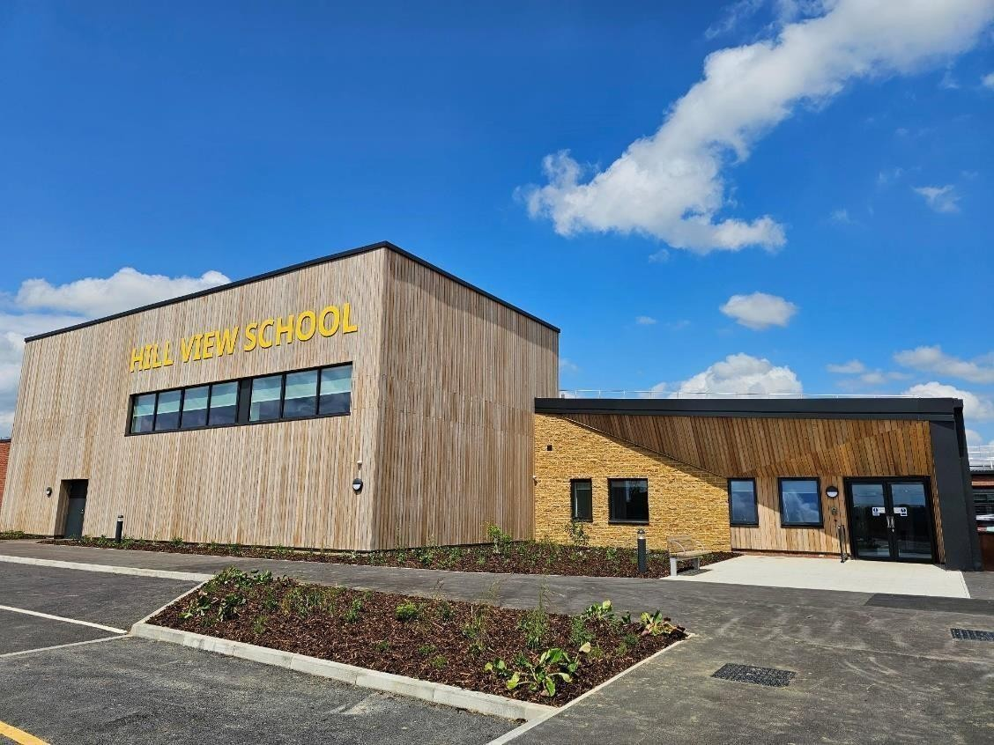

Going to a new school is a big change.
Lot of things will be different.

All the changes may feel uncomfortable at first. It is normal to feel worried and a bit scared when starting a new school.
It is ok to feel worried.

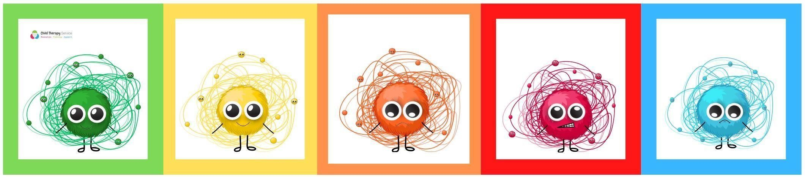

These feelings should go away after the first few weeks.
I can talk to my trusted adults if I feel worried or nervous and my family. They will be able to help me and listen to me.

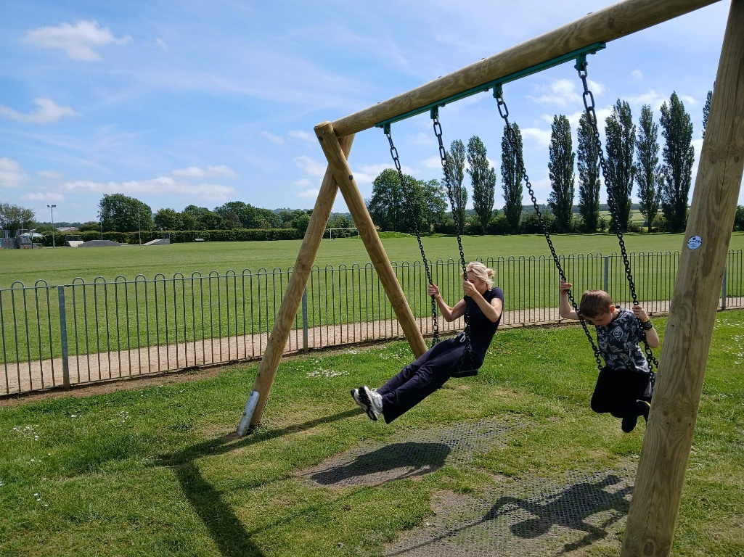

Hill View is on the edge of a village called Ash. It has farm fields around it and helicopters that fly over it. There are gates that open to let people go in and out of the school.
Taxis, minibuses and cars drop people off in the morning and collect them at the end of the day.
The adults from my class will meet me at the start of the day and help me if I need it. The adults from my class will take me out to my transport at the end of the day.
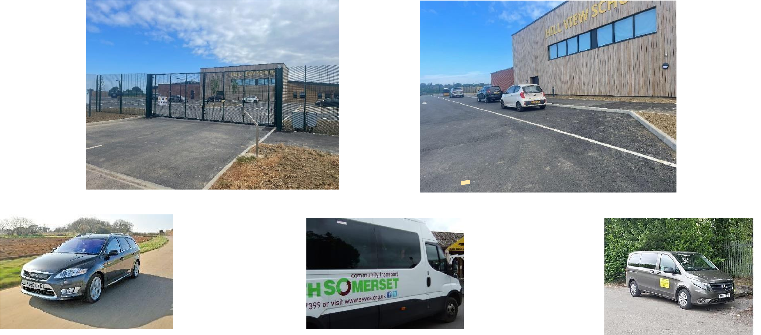
At Hill View the teachers and staff will work differently with me.
In my class there are 3 adults to help me and the other children.
There are lots of adults at Hill View that will get to know me.
Adults will help me to feel safe and will try different ways to help me learn new things.
I will be able to learn things that will help me when I am older and not at school.
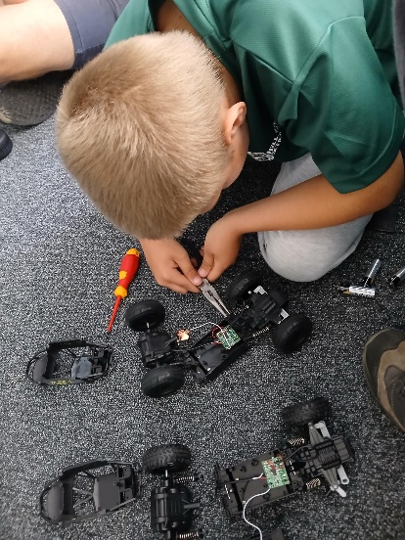
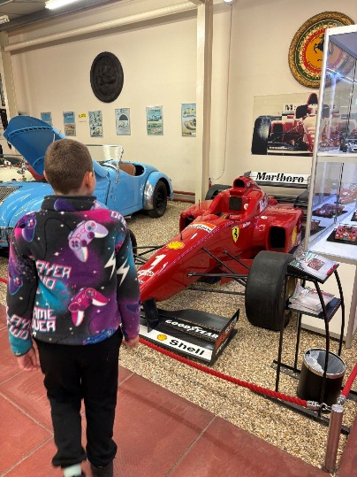
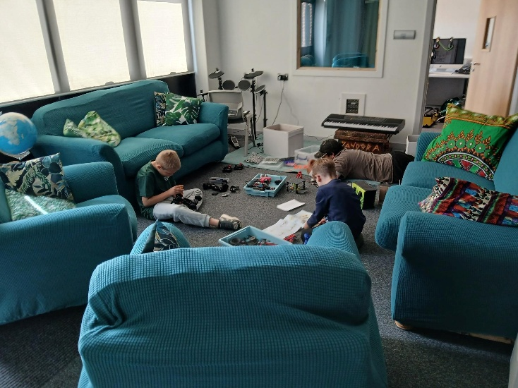

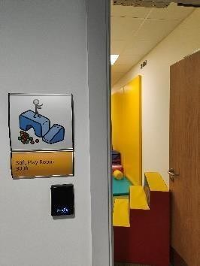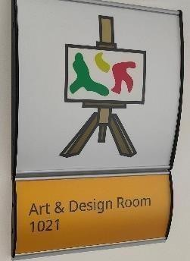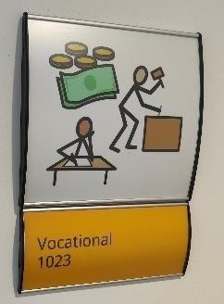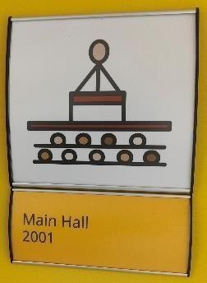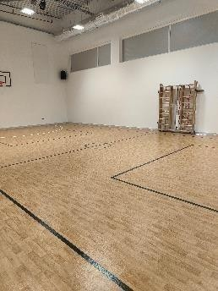

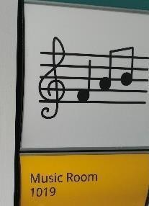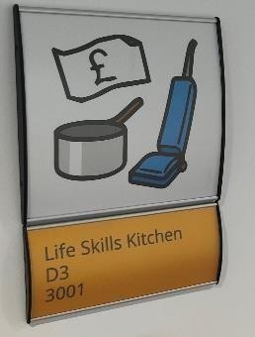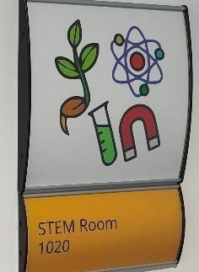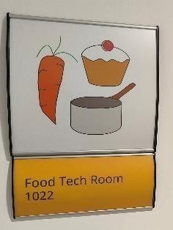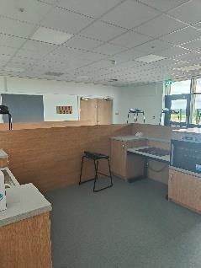

You can look at the Hill View website to see lots more pictures of learning happening at Hill View.

The classroom has a front door and back door, tables and chairs and lots of light.
There is a large cupboard in the classroom where my bag and coat and anything else can be kept safely.
Sometimes I might get upset in the classroom. It is ok to feel upset and a normal part of being me. Adults will be there to help me understand my feelings.
There are spaces in the classroom I can go to if I feel worried, need a quiet space or want to be away from other people. The adults will help me to feel relaxed.
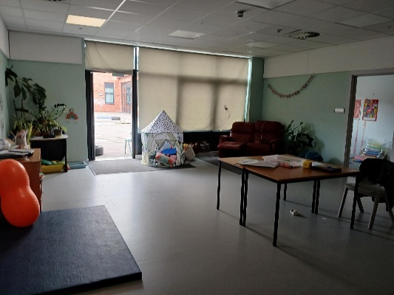
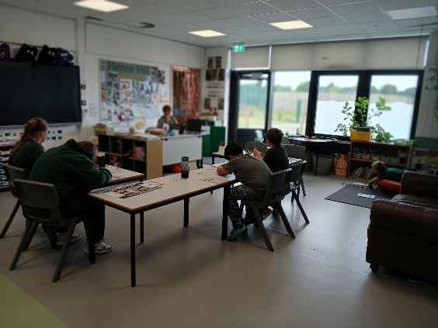
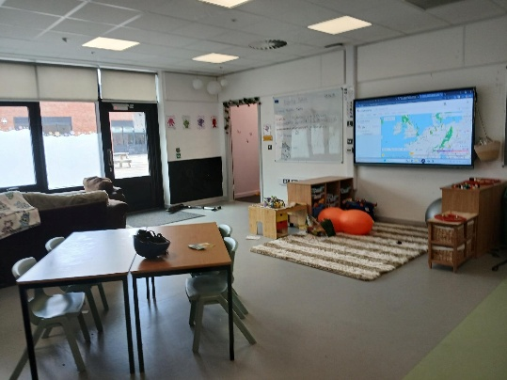
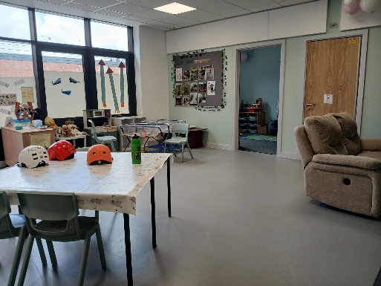

The toilets at Hill View are for one person to use and are a private space.
Some classrooms have a toilet behind a door in the room and some classrooms have a toilet along the corridor.
I can use the sink to wash my hands. I can use the paper towels to dry my hands.
The adults will help me if I need it.

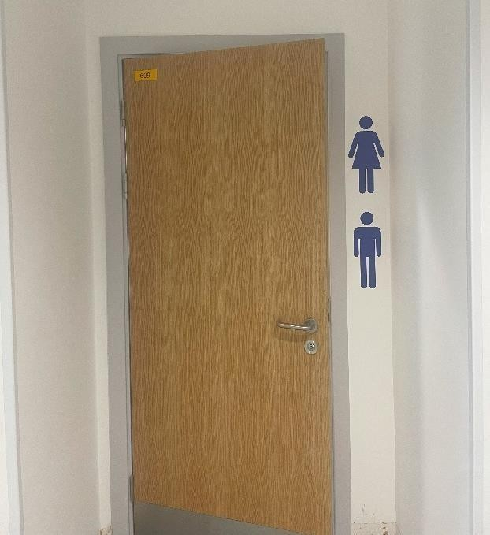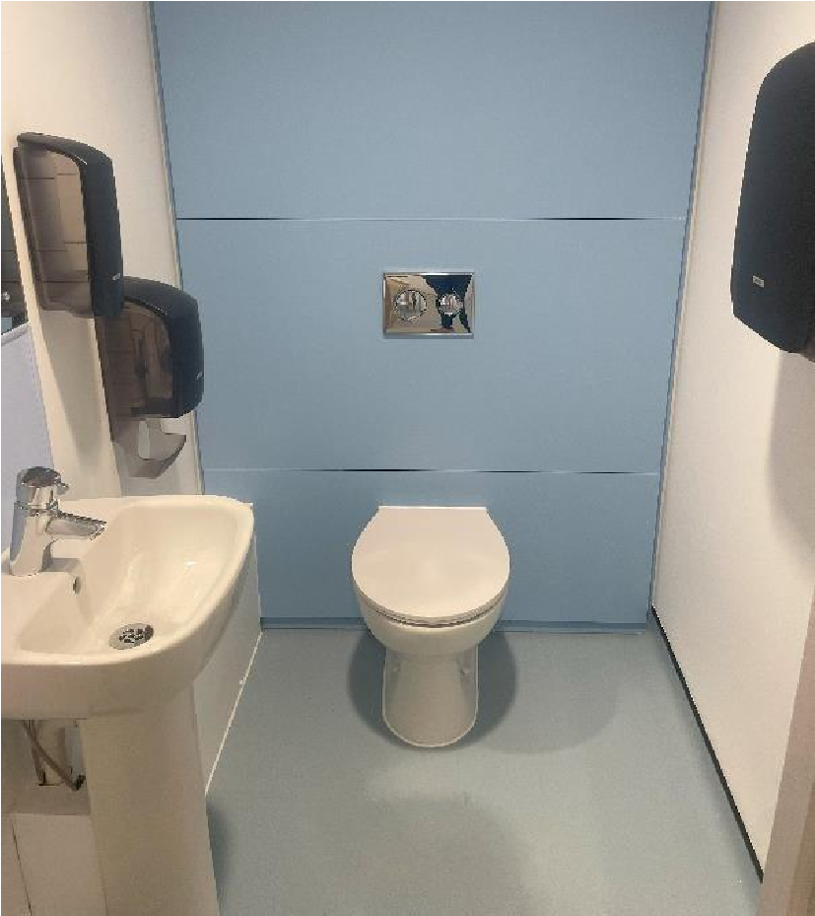

At breaktime and lunchtime there are big outdoor spaces and small outdoor spaces I can go.
At lunch time there is time to relax, time to eat and time to play.
When it is time to eat lunch I can go to a small dining room. Some people have a school meal and some people bring a lunch box.
I might get worried about breaktime and lunchtime.
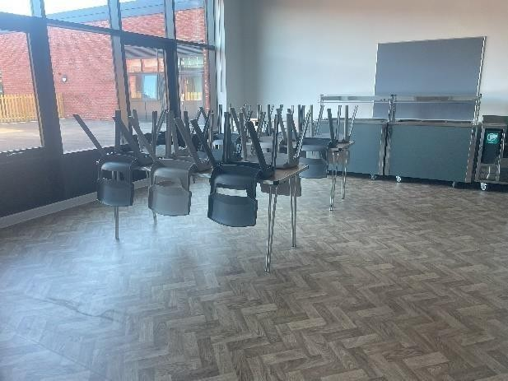
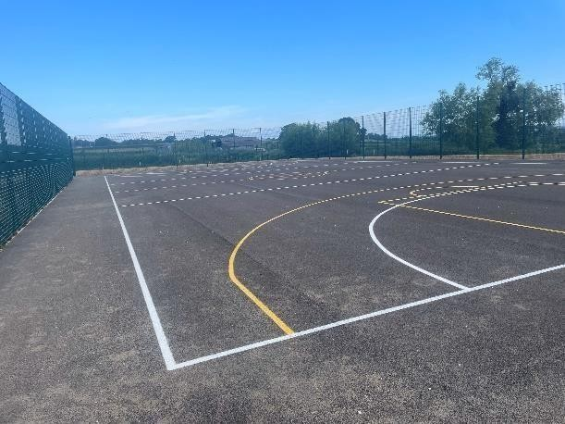
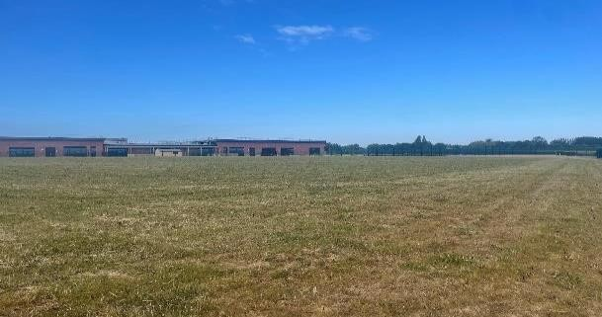
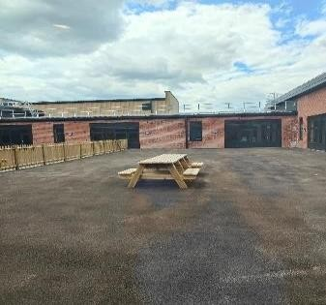
The adults will help me find a space and an activity that will make me feel happy and relaxed.

There is a uniform at Hill View. The uniform for primary school is a green fleece and black bottoms. The uniform for secondary school is a green hoody and black bottoms. A uniform can be uncomfortable to wear and I can talk to the adults in my class about this and I can wear something more comfortable.
I can wear the shoes that I find most comfortable.
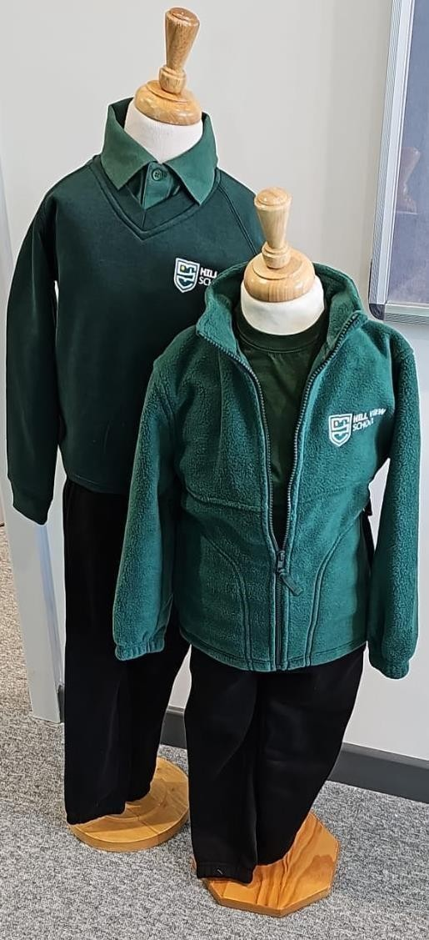
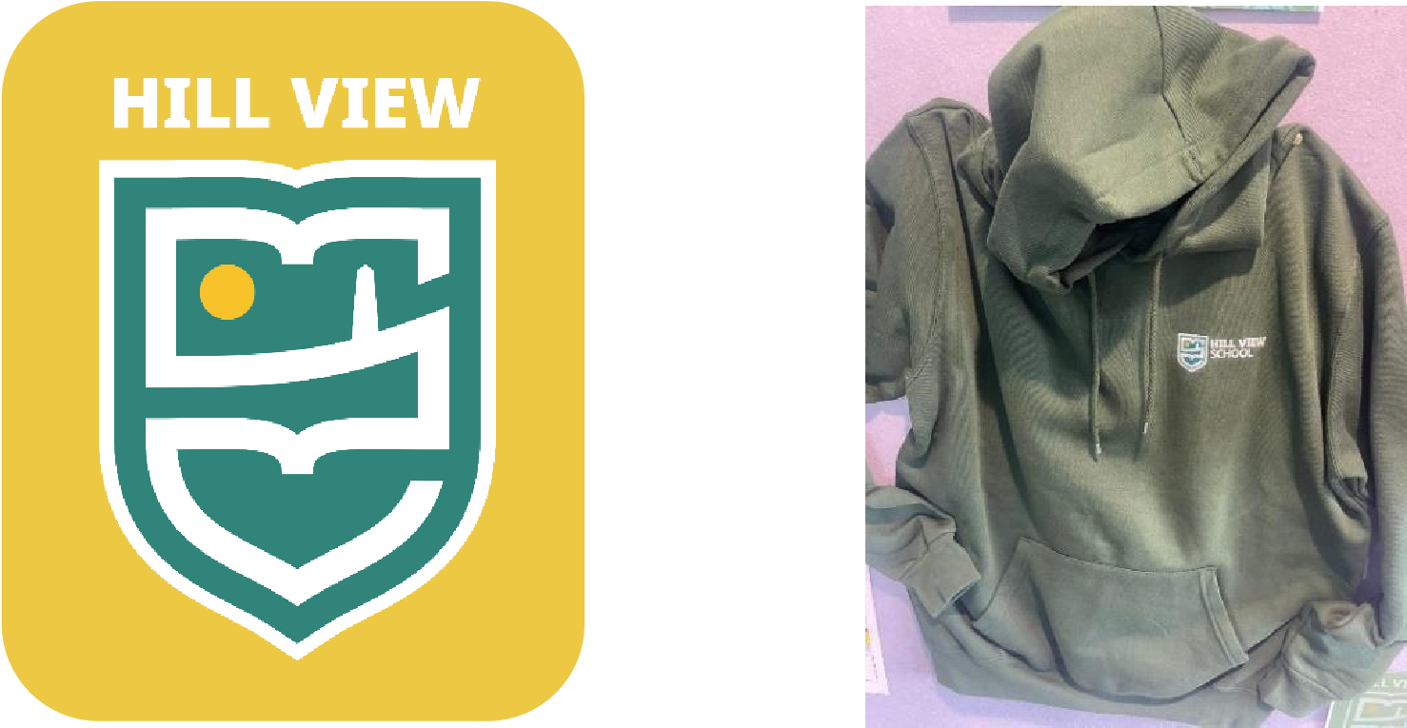
At Hill View, there are some animals that I can spend time with.
If I don’t like animals, that is also okay, I don’t have to spend time with them.
Some of the animals include dogs, chickens, stick insects, rabbits, guinea pigs, gerbil, mice and hamsters.
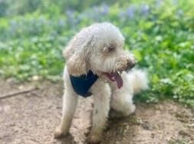

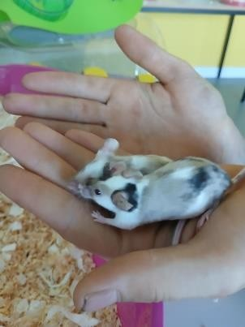
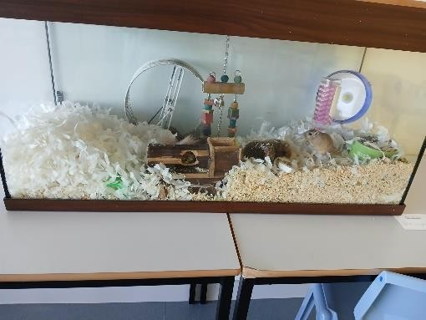
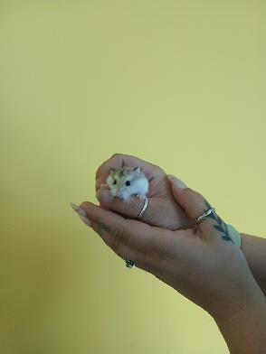

At Hill View adults do not give out detentions or punishments.
The adults help children and young people to learn from making mistakes and practice ways to manage feelings.
School adults and home adults will talk often about the best ways to help me.
If I am worried about anything I have read, I can speak to the adults at Hill View. They really want to help me.

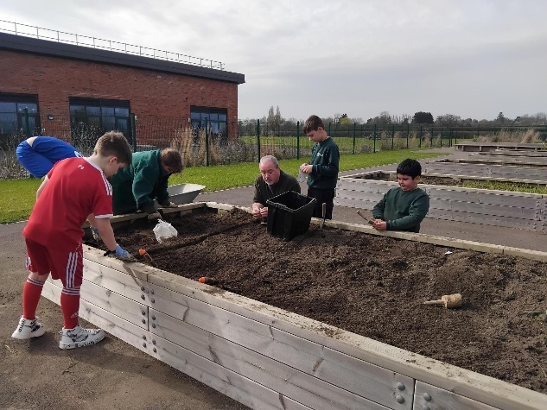 | 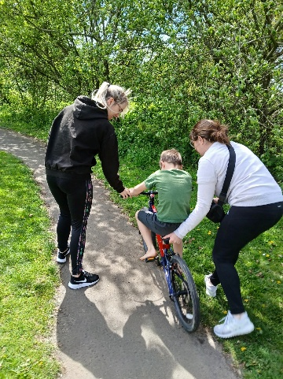 | 

